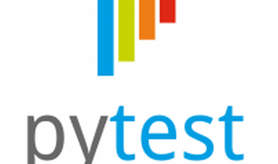

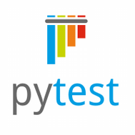

Explore

**Pytest** is a **Python testing framework** that simplifies writing and executing tests, making them more readable and scalable. [It’s particularly useful for both small unit tests and complex functional testing of applications and libraries1](https://docs.pytest.org/)[2](https://pytest-with-eric.com/comparisons/python-testing-frameworks/).

Here are **five free reference links** where you can learn more about pytest:

1. [**Pytest Documentation**](https://docs.pytest.org/): The official pytest documentation provides comprehensive information on installation, usage, and advanced features[3](https://docs.pytest.org/en/7.1.x/explanation/index.html).
2. [**Effective Python Testing With Pytest**](https://realpython.com/pytest-python-testing/): This tutorial covers intermediate and advanced pytest features, including fixtures, marks, parameters, and plugins[4](https://realpython.com/pytest-python-testing/).
3. [**Python Automated Testing with Pytest**](https://codebasics.io/courses/pytest-tutorial-python-automated-testing): A free tutorial on automated testing using pytest, including unit testing and assert statements[5](https://codebasics.io/courses/pytest-tutorial-python-automated-testing).
4. [**Practical Overview of the Top 5 Python Testing Frameworks**](https://pytest-with-eric.com/comparisons/python-testing-frameworks/): Learn about pytest and compare it with other testing frameworks[2](https://pytest-with-eric.com/comparisons/python-testing-frameworks/).
5. [**Software Testing Help - Pytest Tutorial**](https://www.softwaretestinghelp.com/pytest-tutorial/): Dive into the basics of pytest, installation, and usage in this tutorial[6](https://www.softwaretestinghelp.com/pytest-tutorial/).

Happy learning! 🚀🐍